Note: Include this page only when adding / amending / deleting a document. If using this document as a record, this Revision History page can be omitted.

REVISION HISTORY

Revision no | Date | Description of Changes | Reason for Revision | Revised by | Approved by:
00 | Feb. 5, 2016 | Transferred the document from Service Delivery unit to Geniisys Services Unit | SD unit is obsolete | ASRosario | RCGanal
TM-BR-MG-11 Rev02, 10302015

- Objective:
To ensure that training on GENiiSYS system operations is done properly and in detail to minimize problems for client IT.

- Responsibility:

DBA

- References:

- Guidelines
- Workstation Setup Guides:

  - Oracle Forms and Reports Runtime Setup Guide for GenIISys.fmx

    - Installation of Oracle Forms and Reports 6i

1. Double-click setup.exe provided in the 6i folder of the Oracle Forms and Reports installer

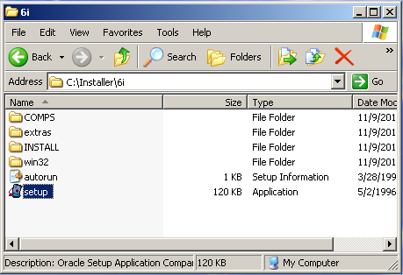

2. Enter your company name and press OK

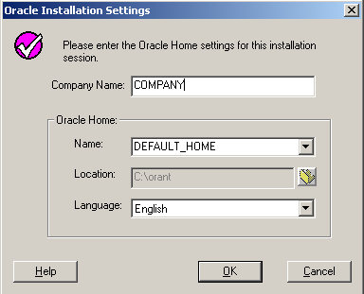

3. Select "Oracle Forms Developer" and press OK

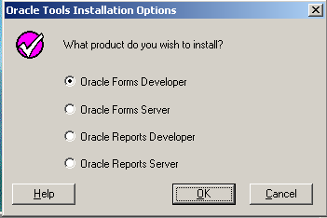

4. Select "Custom" and press OK

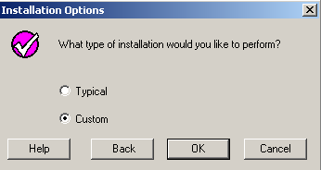

5. Choose Form Runtime 6.0.8.8.0 from the Oracle Forms [EXPORT] 6.0.8.8.0 drop down and click install

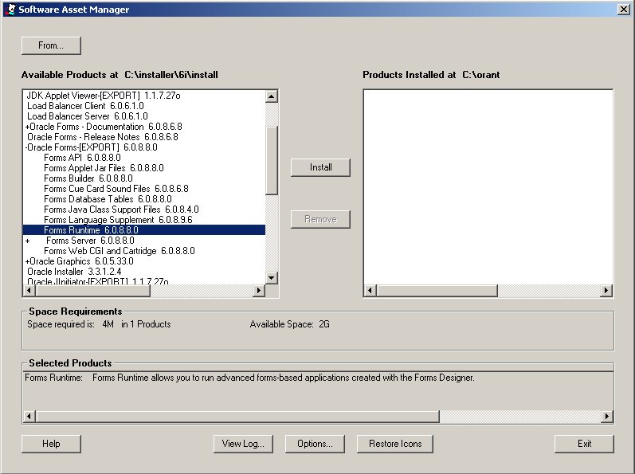

6. Click OK upon pop-up of System Support Files message

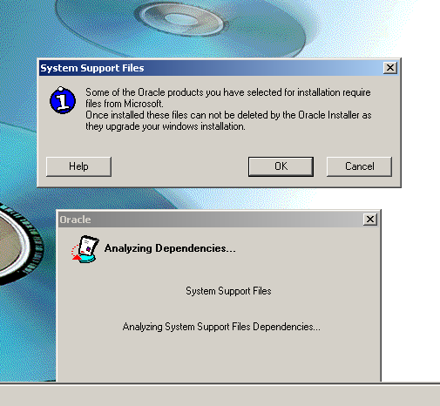

7. Click OK on the General Information message

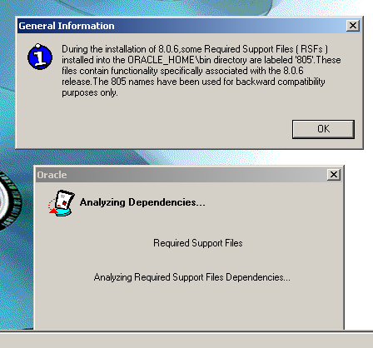

8. Upon successful installation, click OK and exit the installer.

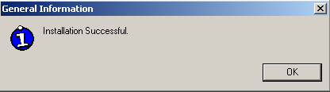

9. Repeat steps 1 and 2 (oracle tools installation options)

10. Choose "Oracle Reports Developer" and click OK

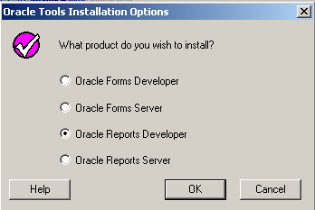

11. Choose "Custom" and click OK

12. Choose Reports Runtime 6.0.8.8.3 under Oracle Reports 6.0.8.8.3 drop down and click install

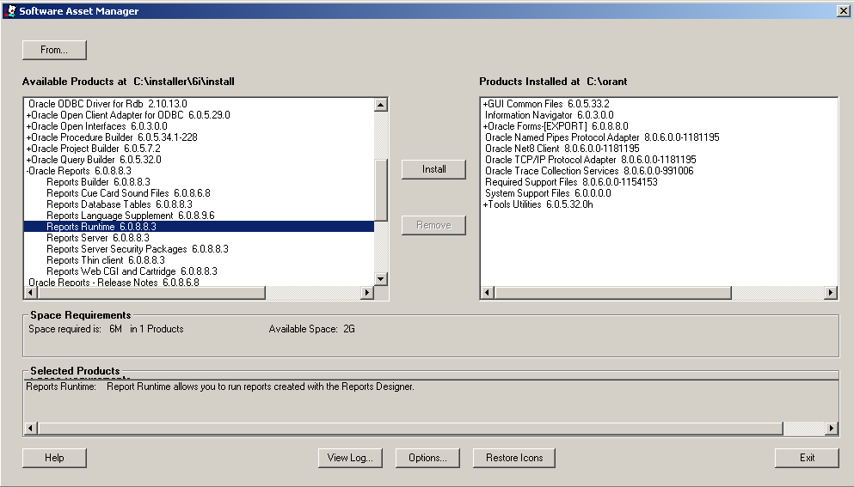

13. Upon successful installation, click OK and exit the installer.

14. Double-click setup.exe provided in the 6ipatch folder of the Oracle Forms and Reports installer to apply the necessary patch update

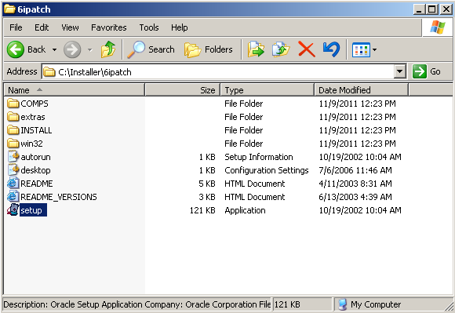

15. Choose "Typical" and click OK

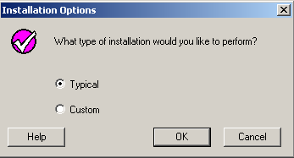

15. Exit Installer afterwards

    - Configuring Regedit

* registry for 64-bit workstations should be edited in HKEY_LOCAL_MACHINE\SOFTWARE\Wow6432Node\ORACLE
*registry for 32-bit workstations should be edited in HKEY_LOCAL_MACHINE\SOFTWARE\ORACLE

The following registry values should be edited. Values not present should be created as well. the path of the registry value will depend on the shared network location of the GenIISys files (ex. \\geniisys\geniisys6i\Final\Fmx ).

***FORMS60_PATH***
\\geniisys\geniisys6i\Final\Fmx;\\geniisys\Geniisys6i\Template6i;\\Geniisys\Geniisys6i\icons6i;C:\orant\TOOLS\OPEN60\PLSQLLIB;\\Geniisys\Geniisys6i\Template6i;\\Geniisys\Geniisys6i\Final\Fmx
***D2KWUTIL60_PATH***
\\Geniisys\Geniisys6i\Template6i
***UI_ICON***
\\Geniisys\Geniisys6i\icons6i
***REPORTS60_PATH***
\\geniisys\geniisys6i\Final\Rep;\\Geniisys\Geniisys6i\Template6i;\\Geniisys\Geniisys6i\icons6i;C:\orant\REPORT60\ADMIN\TEMPLATE\US;C:\orant\REPORT60

    - Configuring connection through TNSNAMES.ora setup

Setup of Tnsnames.ora
Before you can be able to connect to the database, the Tnsnames.ora should have been setup properly. This is a text file that contains values needed by the PC to connect to a database. Without the right values in the tnsnames.ora, the PC cannot connect to the specified database. The tnsnames.ora acts like a directory of database to which the PC can connect to.

Edit the TNSNAMES located in %ORACLE_HOME%\network\admin

Example of tnsnames.ora entry:

geniisys.world =
(DESCRIPTION =
(ADDRESS_LIST =
(ADDRESS =
(COMMUNITY = tcp.world)
(PROTOCOL = TCP)
(Host = 192.10.10.105)
(Port = 1521)
)
)
(CONNECT_DATA = (SID = geniisys)
)
)

The values that need to be supplied:
- Service Name => example: geniisys.world, BACKUP.world
- Host => example: 192.10.10.105, Server1, 192.10.10.101
- SID => example: geniisys, BACKUP

    - Configuring GenIISys.fmx shortcut

Create a shortcut on the workstation desktop pointing to the geniisys.fmx shared file on the fileserver.

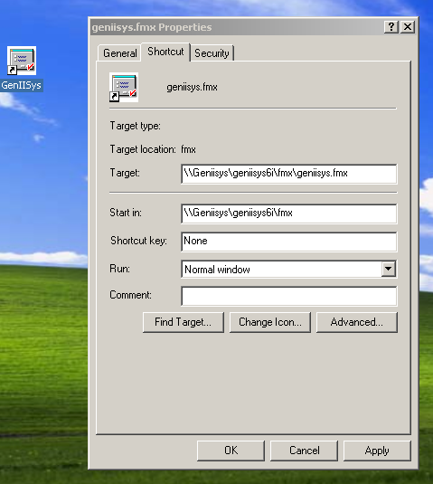

  - PATH and CLASSPATH Setup Guide

PATH and CLASSPATH is an environment variable used by the user workstation to gain access to different GenIISys functionality such as CSV reporting/generation as well as uploading.

Make sure that java folder, CSV_LIB.pll and CSV_LIB.plx is present in the network shared template6i folder (ex. \\Geniisys\Geniisys6i\Template6i)

Modify ENVIRONMENT VARIABLES. Go to My Computer then right click> choose Properties > choose Advanced > Environment Variables. Add values in PATH and create CLASSPATH.
* Replace C:\Geniisys\Template6i with the appropriate Geniisys directory you are using (ex. \\Geniisys\Geniisys6i\Template6i) . Find the directory where you paste the java folder. Open it as for directory indicated below.

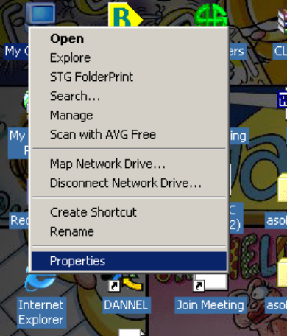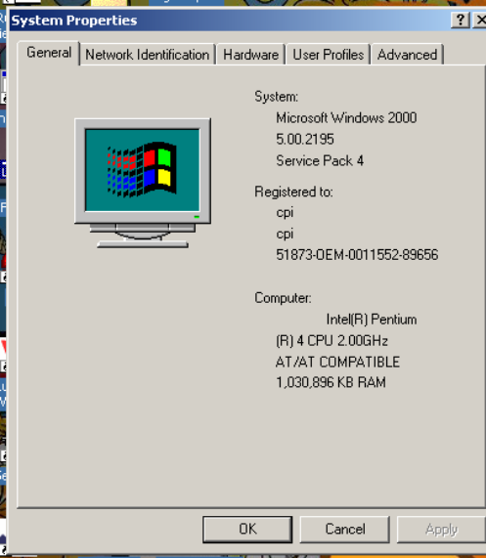

modify PATH
C:\Geniisys\Template6i\java\jre1.6.0\lib;C:\Geniisys\Template6i\java\jre1.6.0\bin;C:\Geniisys\Template6i\java\jre1.6.0\bin\client

Add/modify CLASSPATH
C:\Geniisys\Template6i\java\jar;C:\Geniisys\Template6i\java\jar\csvparser1.0.jar;C:\Geniisys\Template6i\java\jar\c3p0-0.9.1-pre11-jdk1.3.jar;C:\Geniisys\Template6i\java\jar\ojdbc14.jar;C:\Geniisys\Template6i\java\jar\opencsv-1.7.jar; c:\orant\TOOLS\COMMON60\JAVA\IMPORTER.JAR

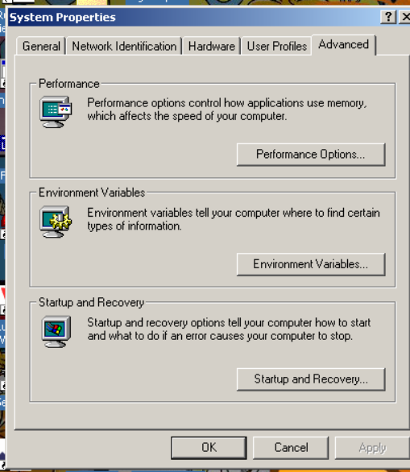

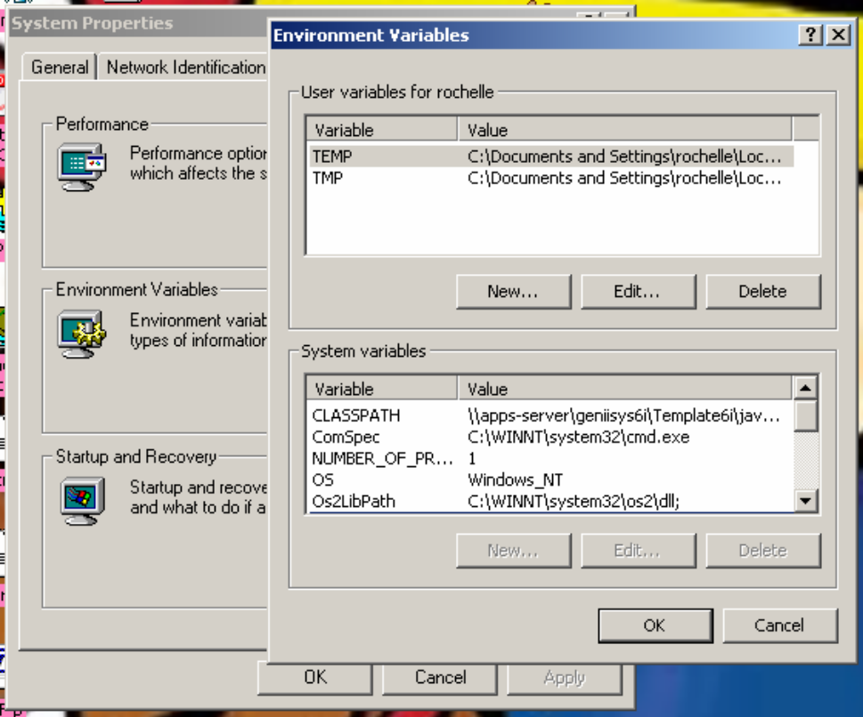

NOTE: restart the computer after set-up of the PATH and CLASSPATH

  - Setup GENWEB in Firefox

  - Additional Setup Required

    - Java Runtime Environment (JRE)

Download and install jre-6u24-windows-i586.exe on the workstation for Windows 32-bit OS and jre-6u24-windows-x64.exe for Windows 64-bit OS.

    - WordViewer (refer to system administrator for installation)

    - MS Word and MS Excel (refer to system administrator for installation)

    - Misc Patches (refer to system administrator for installation if any)

- Installing Network Printers on Genweb

- Terminal Server Setup (please see I. )

- Backup Plan

  - Backup and recovery for GenIISys Database

An oracle backup is a copy of data that can be used to restore the original data in cases of data loss. The backup may include the control file, archive logs and data files. Without a proper backup strategy, recovering the database from a failure may not be possible. The backup strategy should always be made for the requirements of the data.

Redo Log Files:

Noarchive Log Mode – When the database is operated in Noarchive Log Mode, redo log files are not copied and saved as archive log files. This means that the only recovery for media failure is to restore the last consistent whole database backup. Consistent whole database backups are taken while the database is shutdown. Backups should be performed on a schedule according to the amount of work that is acceptable to loss.

Archive Log Mode – When the database is operated in Archive Log Mode, redo log files are copied and saved as archive log files. This means that the archive logs, redo logs, and data file backups can be used for complete recovery to the point of failure or any previous amount in time.

Backup Methods:
There are several methods to backup the database. We can use the Recovery Manager (RMAN) utility, Physical Backup or Logical Backup.

RMAN – is a utility that establishes connection with a server session and manages the movement of data for backup and recovery operations.

Physical Backup – a physical database backup is a backup of the database files that is performed using operating system facilities while the database is open or closed.

Logical Backup – logical backups uses the Oracle Export utility to make logical backups. The utility writes data from an Oracle database to operating system files in a propriety format. The counterpart of the export utility is the import utility.

Performing Logical Backups

The Export Utility

Export Modes:
- Table Mode – uses the TABLE parameter
Table definitions
Table data
Owner’s grants
Owner’s indexes
Table constraints
Table triggers
- User Mode – uses the USER parameter
Table mode +
Clusters
Database links
Views
Private synonyms
Sequences
Snapshots
Snapshots logs
Stored procedures
- Full Database Mode – uses the FULL=Y parameter
User Mode +
Roles
All synonyms
System Privileges
Tablespace quotas
Rollback segment
Definitions
System audit options
All triggers
Profiles

The following are valid EXPORT commands:

Format: EXP KEYWORD = VALUE OR KEYWORD=(VALUE1,VALUE2…VALUEN)
Example: EXP SCOTT/TIGER GRANTS=Y TABLES=(EMP,DEPT,MGR)

Keyword Description (Default)

USERID username/password
BUFFER size of data buffer
FILE output files (EXPDAT.DMP)
COMPRESS import in one extent (Y)
GRANTS export grants (Y)
INDEXES export indexes (Y)
ROWS export data rows (Y)
CONSTRAINTS export constraints (Y)
LOG log file of screen output
DIRECT direct path
FEEDBACK display progress every x rows (0)
FILESIZE maximum size of each dump file
FULL export entire file (N)
OWNER list of owner usernames
TABLES list of table names
RECORDLENGTH length of IO record
INCTYPE incremental export type
RECORD track incr. Export (Y)
PARFILE parameter filename
CONSISTENT cross-table consistency
STATISTICS analyze objects (ESTIMATE)
TRIGGERS export triggers (Y)

The following keywords only apply to transportable tablespaces:
- TRANSPORT_TABLESPACE - export transportable tablespace metadata (N)
- TABLESPACES - list of tablespaces to transport

The Import Utility
The import utility allows the restoration of database information held in previously created export files.

To recover a database using Export files and Import utility:
- Recreate the database structure, including all tablespaces and users (these recreated structures should not have objects in them)
- Import the appropriate Export files to restore the database to the most current state possible. Depending on how your Export schedule is performed, imports of varying degrees will be necessary to restore a database.

The following are valid IMPORT commands:

Format: IMP KEYWORD=value or KEYWORD=(value1,value2,...,valueN)
Example: IMP SCOTT/TIGER IGNORE=Y TABLES=(EMP,DEPT)

Keyword Description (Default)

USERID username/password
BUFFER size of data buffer
FILE input files (EXPDAT.DMP)
SHOW just list file contents (N)
IGNORE ignore create errors (N)
GRANTS import grants (Y)
INDEXES import indexes (Y)
ROWS import data rows (Y)
LOG log file of screen output
DESTROY overwrite tablespace data file (N)
INDEXFILE write table/index info to specified file
SKIP_UNUSABLE_INDEXES skip maintenance of unusable indexes (N)
ANALYZE execute ANALYZE statements in dump file (Y)
FEEDBACK display progress every x rows(0)
TOID_NOVALIDATE skip validation of specified type ids
FILESIZE maximum size of each dump file
RECALCULATE_STATISTICS recalculate statistics (N)
FULL import entire file (N)
FROMUSER list of owner usernames
TOUSER list of usernames
TABLES list of table names
RECORDLENGTH length of IO record
INCTYPE incremental import type
COMMIT commit array insert (N)
PARFILE parameter filename
CONSTRAINTS import constraints (Y)

The following keywords only apply to transportable tablespaces:

- TRANSPORT_TABLESPACE - import transportable tablespace metadata (N)
- TABLESPACES - tablespaces to be transported into database
- DATAFILES - datafiles to be transported into database
- TTS_OWNERS - users that own data in the transportable tablespace set

Performing RMAN Back up
Another recommended database back up is using the RMAN utility. Recovery Manager (or RMAN) is an Oracle provided utility for backing-up, restoring and recovering Oracle Databases. RMAN ships with the database server and doesn't require a separate installation. The RMAN executable is located in your ORACLE_HOME/bin directory.

RMAN can be operated from Oracle Enterprise Manager, or from command line. Here are the command line arguments:
Argument Value Description
---------------------------------------------------------------------------------------------------------------------------
target quoted-string connect-string for target database
catalog quoted-string connect-string for recovery catalog
nocatalog none if specified, then no recovery catalog
cmdfile quoted-string name of input command file
log quoted-string name of output message log file
trace quoted-string name of output debugging message log file
append none if specified, log is opened in append mode
debug optional-args activate debugging
msgno none show RMAN-nnnn prefix for all messages
send quoted-string send a command to the media manager
pipe string building block for pipe names
timeout integer number of seconds to wait for pipe input
--------------------------------------------------------------------------------------------------------------------------
To execute a simple back up using RMAN on command line just run the following command:
C:\> rman target sys/<password>@<database_name> nocatalog
RMAN> backup database;
After the back up, you can leave RMAN by issuing the command:
RMAN> quit

To back up the database, it is important that the archive log mode is on to do this. The main reason for running in archivelog mode is that one can provide 24-hour availability and guarantee complete data recoverability. It is also necessary to enable ARCHIVELOG mode before one can start to use on-line database backups.

Issue the following commands to put a database into ARCHVELOG mode:
C:\> sqlplus sys/<password>@<database_name> AS SYSDBA
SQL> STARTUP MOUNT EXCLUSIVE;
SQL> ALTER DATABASE ARCHIVELOG;
SQL> ARCHIVE LOG START;
SQL> ALTER DATABASE OPEN;
Note: Make sure that the database is shutdown/off line before executing the commands. If it is still on line, make sure that no user is connected to the database then execute the following command:
SQL> CONNECT sys AS SYSDBA
SQL> SHUTDOWN NORMAL

The following parameters needs to be set for databases in ARCHIVELOG mode:
log_archive_start = TRUE
log_archive_dest_1 = 'LOCATION=/arch_dir_name'
log_archive_dest_state_1 = ENABLE
log_archive_format = %d_%t_%s.arc
The parameters can be edited on the pfile of the database which can be found either $ORACLE_BASE/admin/SID/pfile or $ORACLE_HOME/admin/SID/pfile where SID is the name of the database and $ORACLE BASE or $ORACLE HOME is the directory/location where oracle database is installed.

Performing RMAN Recovery
To recover the database using the RMAN utility, connect to RMAN by issuing the command:
C:\> rman target sys/<password>@<database_name> nocatalog
Make sure that there is a existing back up of the database to be able to recover. You can see the list of the back up set by issuing the command:
RMAN> list backup;
To restore the database, issue the command:
RMAN> restore database;
At this point you'll need to attempt a recovery of the database. Normally a recovery is preformed by applying all the archivelogs against the instance. Run the following command to start recovery:
RMAN> recover database;
You can also refer to the Oracle Online Documentation for other methods in back up and recovery using RMAN. RMAN can also be used in recovering corrupt/damaged datafiles and tablespaces, please refer to the Oracle Online Documentation for the detailed process.

Backup Procedure for GenIISys Database

- The schedule of backup will be as follows:
- Full (complete) export on the first day of the month.
- Cumulative export every Friday of the week.
- Incremental export every day.
- Note: Export should be done only after office hours. Make sure that no other user is connected except for CPI, while exporting the database.

- You can decide to make a batch file for each of the following export commands. In this way, it would just take you a click of the mouse on a shortcut icon to run the export utility.

Full (Complete) Export:
C:\> exp system/prod@geniisys FILE=F:\BACKUP\geniisys_full.dmp
LOG=F:\BACKUP\geniisys_full.log INCTYPE=complete FULL=y

Cumulative Export:
C:\> exp system/prod@geniisys FILE=F:\BACKUP\geniisys_cumu.dmp
LOG=F:\BACKUP\geniisys_cumu.log INCTYPE=cumulative FULL=y

Incremental Export:
C:\> exp system/prod@geniisys FILE=F:\BACKUP\geniisys_incre.dmp
LOG=F:\BACKUP\geniisyscomp.log INCTYPE=incremental FULL=y

- After exporting the database, you can choose to compress the file using any file compression software like winzip to minimize disk usage. And you can also choose to make a copy or simply transfer the zipped file to a tape or any backup media.

Recovery Procedure for GenIISys Database

- After the failure, the database should be recreated as it was.
- Retrieve the latest backup – that is the latest complete backup and all incremental and cumulative backup following the latest complete backup.
- Unzip all the files.
- If the last backup is a complete backup, then recovering the database using it will be enough to restore the database to its original form. To recover the complete backup:

>> imp system/prod@dgeniisys FILE=F:\BACKUP\’Unzipped_file’ INCTYPE=restore FULL=Y

- If the last backup is not a complete backup then do the following steps. Recover the system from the latest backup:

>> imp system/prod@dgeniisys FILE=F:\BACKUP\’Unzipped_file’ INCTYPE=system FULL=Y

- If the latest backup is a cumulative backup then restore all cumulative and complete backup only. To recover the database in this case do the folllowing:

>> imp system/prod@dgeniisys FILE=F:\BACKUP\’Unzipped_file’ INCTYPE=restore FULL=Y

* Importing should start with complete backup to the latest cumulative backup in chronological order.

- If the latest backup is an incremental backup then restore all backup. To recover the database in this case do the following:

imp system/prod@dgeniisys FILE=F:\BACKUP\’Unzipped_file” INCTYPE=restore FULL=Y

* Importing should start with the complete backup up to the latest incremental backup in chronological order.

NOTE: If you prefer to use Recovery Manager, please refer to Oracle8 Recovery Manager User's Guide and Reference using the Oracle Online Documentation CD.

  - Backup and recovery for GenIISys Application

The GenIISys Application consists of modules, reports, templates, and libraries. Generally, it is easier to backup the application because it is done physically in the windows environment. The basic operations include the copying of file to a secured media like tapes, zip diskettes, or another hard disk.

The files with the following types/extensions should be backup:
- *.FMX
- *.RDF
- *.REP
- *.MMX
- *.PLL
- *.PLX
- *.PRT
- *.SQL

Basically, the files are located in one main directory called GenIISys. This directory contains subdirectories that separate the application for underwriting, accounting, and claims. In summary, all subdirectories and files in GenIISys directory should be should be copied/backuped regularly to a secured storage. To recover damages files, simply replace the file with the backup file.

- Service Request Reporting through Mantis

- Recreating DEVT database

1.) Run this script on the LIVE server to get the CREAT TABLESPACE scripts.

DECLARE
c CLOB;
BEGIN
FOR t IN (SELECT tablespace_name
FROM dba_tablespaces)
LOOP
SELECT DBMS_METADATA.get_ddl ('TABLESPACE',t.tablespace_name)
INTO c
FROM DUAL;
DBMS_OUTPUT.put_line (c || ';');
END LOOP;
END;

2.) Edit the paths you want to place the datafiles to in the DEVT/test server

3.) Perform a full EXPORT using this command

>>exp system/password@SID file=c:\filename.dmp log=c:\logname.log full=y buffer= 104857600 statistics=none

4.) Install Oracle database software 10gR2 on the DEVT/TEST server.

5.) Create oracle database and make sure to specify these values on the parameters
a.) processes = 1000
b.) open_cursors = 1500
c.) resource_limit = TRUE
d.) session_cached_cursors = 100 (this parameter should only be set if you have a large amount of RAM, 16gig or more)

7.)create 6 redo log groups with atleast 3 log members per group. Size the redo log according to how many transaction your database handles. Usually a size of 50MB to 150MB is acceptable for GenIIsys. Make sure to place log members to physically different hard disks.

8.) Import the dump using this script
>>imp system/password@SID file=c:\filename.dmp
log=c:\logname.log
full=y
buffer= 104857600
statistics=none

9.) Gather database statistics using this script
BEGIN
SYS.DBMS_STATS.GATHER_DATABASE_STATS (
Granularity => 'DEFAULT'
,Options => 'GATHER'
,Gather_Temp => FALSE
,Gather_Sys => FALSE
,Estimate_Percent => NULL
,Degree => 4
,Cascade => TRUE
,No_Invalidate => TRUE);
END;
/

--make sure that there is no need to run these scripts:
create public synonym dbms_sys_sql for sys.dbms_sys_sql;
grant execute on dbms_sys_sql to public;
grant execute on dbms_sys_sql to users;

--if there is a problem on CPI.ORA_PIPE, connect as sys and do the ff:
GRANT EXECUTE ON dbms_pipe TO PUBLIC;
GRANT EXECUTE ON dbms_pipe TO users;
CREATE OR REPLACE PUBLIC SYNONYM dbms_pipe FOR sys.dbms_pipe;

--if package DO_DDL becomes invalid, connect as sys and do the ff:
CREATE OR REPLACE PUBLIC SYNONYM DBMS_SYS_SQL FOR SYS.DBMS_SYS_SQL;
GRANT EXECUTE ON dbms_sys_sql TO PUBLIC;

